*Quality Learning and Superior Performance for All*

**PURCHASING DEPARTMENT**

l36 Almon C. Hill Dr., Cumming, GA 30040

Phone: 770-781-6603 Fax: 770-888-0222

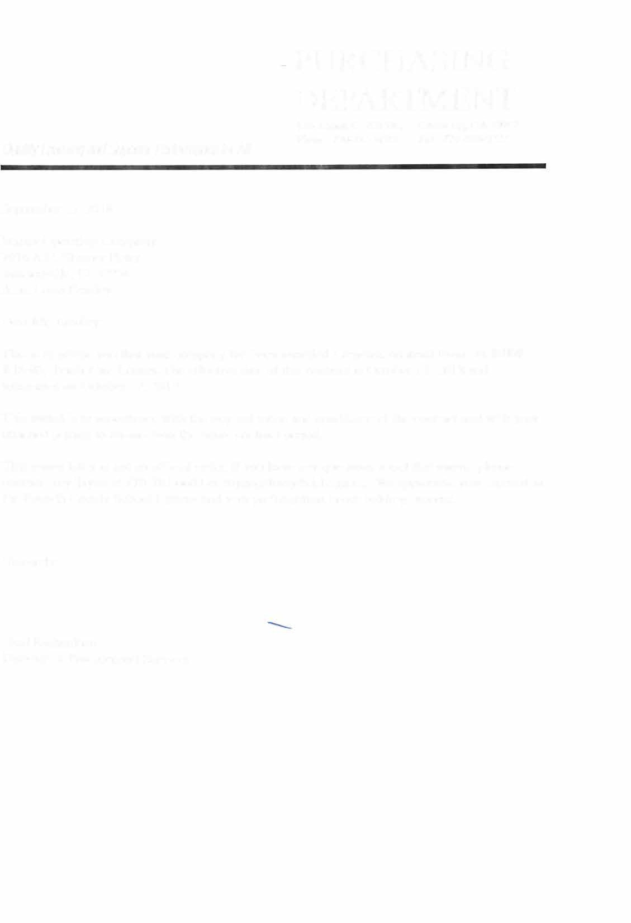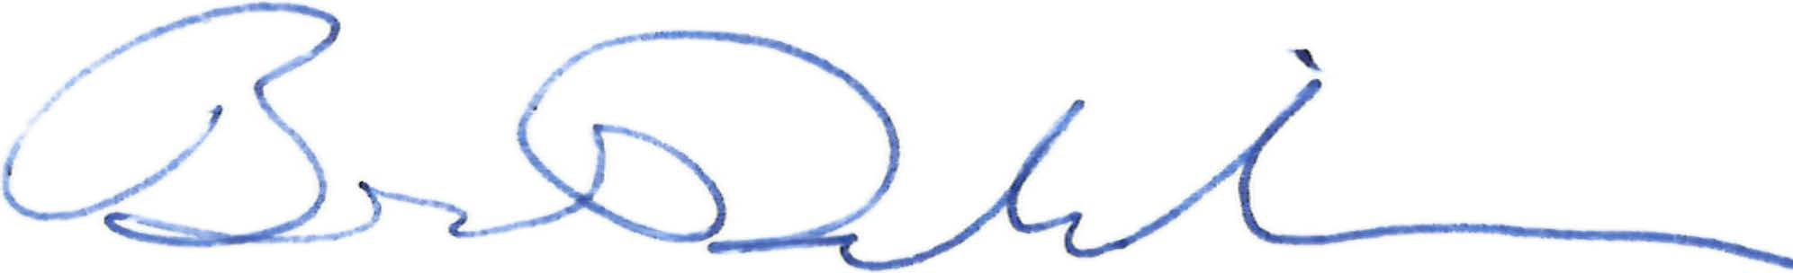

September 25, 2018

Veritiv Operating Company 7016 A.C. Skinner Pkwy Jacksonville, FL 32256 Attn: Colin Bradley

Dear Mr. Bradley:

This is to advise you that your company has been awarded a renewal contract from our **BID# BlS-03, Trash Can Liners.** The effective date of this contract is October 18, 2018 and terminates on October 17, 2019.

This award is in accordance with the original terms and conditions of the contract and with your attached pricing to remain firm the entire contract period.

This award letter is not an official order. If you have any questions about this award, please contact Trey Tryan at 770-781-6603 or [ttryan@forsyth.k12.ga.us.](mailto:ttryan@forsyth.k12.ga.us) We appreciate your interest in the Forsyth County School System and your pai1icipation in our bidding process.

Sincerely:

Brad Richardson

Director of Procurement Services

# FORSYTH COUNTY SCHOOL SYSTEM

PURCHASING DEPARTMENT

| Bid B18-03, Trash Can Liners | Veritiv Operating Company | | | |
| --- | --- | --- | --- | --- |
| Make & Model Bid | Delivery Time | Qty Per Case | Case Cost |
| Large Can Liner Pre-Approved By FCSS | Berry MX3750- 30MB | 3 Weeks | 150 | $23.89 |
| Small Can Liner Pre-Approved By FCSS | Berry MX2431- 15C | 3 Weeks | 500 | $17.03 |